




Virginia State Police (VSP)

CCH Seal

Business Screening Services
Seal Notification Services

Interface Control Document

Version 1.0

Table of Contents
DOCUMENT IDENTIFICATION iii
REVISION HISTORY iii
ACRONYMS iii
1. Introduction 2
1.1. Business Purpose 2
1.2. High Level Overview 3
1.3 Account and Billing Setup 4
1.4 Seal Notification Workflow 5
1.5 Seal Order Notification Email 6
1.6 Seal Order Notification Portal 7
2. File Specifications 8
2.1. File Format 8
2.2. File Definition 8

DOCUMENT IDENTIFICATION
Identification | Description
Document Name | Business Screening Service Seal Notification Services
Project Name | Virginia State Police CCH Seal
Project Sponsor(s) Name | Captain Julia Gunderson
Project Manager | Robert Bradshaw
Document Version | 1.0
Date Last Updated | 4/1/2026
Table 1: Document Identification

REVISION HISTORY
Version | Date | Modifications | Prepared By
Table 2: Document Edit History

ACRONYMS
Acronym | Description
BA | Business Analyst
CCH | Computerized Criminal History System
CHRI | Criminal History Record Information
CJIS | Criminal Justice Information System
COV | Code of Virginia
DCN | Document Control Number
FBI | Federal Bureau of Investigation
ICD | Interface Control Document
MFT | Managed File Transfer
OTN | Offense Tracking Number
PII | Personal Identifiable Information
SME | Subject Matter Expert
VSP | Virginia State Police
Table 3: Acronyms Used in this Document

1. Introduction

1.1. Business Purpose
The Virginia Business Screening Services (BSS) program is a state-mandated initiative regulated by the Virginia State Police (VSP) under Virginia Code § 19.2-392.16. It requires businesses handling Virginia criminal and traffic history records to register and comply with specific regulations to ensure proper management of sensitive information. This document describes the services and interface between VSP Computerized Criminal History (CCH) system and external stakeholders (Business Screening Services companies) for the orchestration of the sealing of criminal history records in accordance with Virginia Code. It is the responsibility of any entity that maintains Virginia criminal history records to take appropriate action to seal offenses in accordance with the legislation.

For the purposes of this ICD, the applicable details of this legislation are hereunto referred to as Automatic Sealing, the effects of which is provided in §19.2-392.5, are comprised of the following:
- Seal by Petition (§19.2-392.12)
- Automatic Sealing - OES Initiated (§19.2-392.8, §19.2-392.10)
- Automatic Sealing - VSP Initiated (§19.2-392.6, §19.2-392.7, §19.2-392.11, §19.2-392.17)
- Seal Dissemination - §19.2-392.13

The following services are provided to facilitate the communication of seal notifications to BSS companies to support the sealing of criminal history records:
- Account and Billing set up
- Seal Alert Notification Emails
- Seal Notification Portal for downloading seal notification files and acknowledgement

1.2. High Level Overview

- BSS company requests license to Seal Order Notifications
- VSP reviews the request and if approved:
  - VSP sends contract and registration form to the requester
  - The requester provides additional information (Users & Billing info), signs contract and submits form
  - The requester submits payment
  - VSP & VITA to set up users and provide login information
- VSP will generate Seal Order file on a periodic basis (currently daily)
- VSP will send a notification email to the BSS company with link to VSP Seal Order Notification Portal each time a file is created
- BSS company will log in to Portal and download file. (Download of file will be considered acknowledgement of the Seal Order information)
- BSS company will take appropriate action in their systems
- VSP will log the acknowledgement for tracking purposes.

1.3 Account and Billing Setup
The following process flow diagram presents flow for Account and Billing setup:
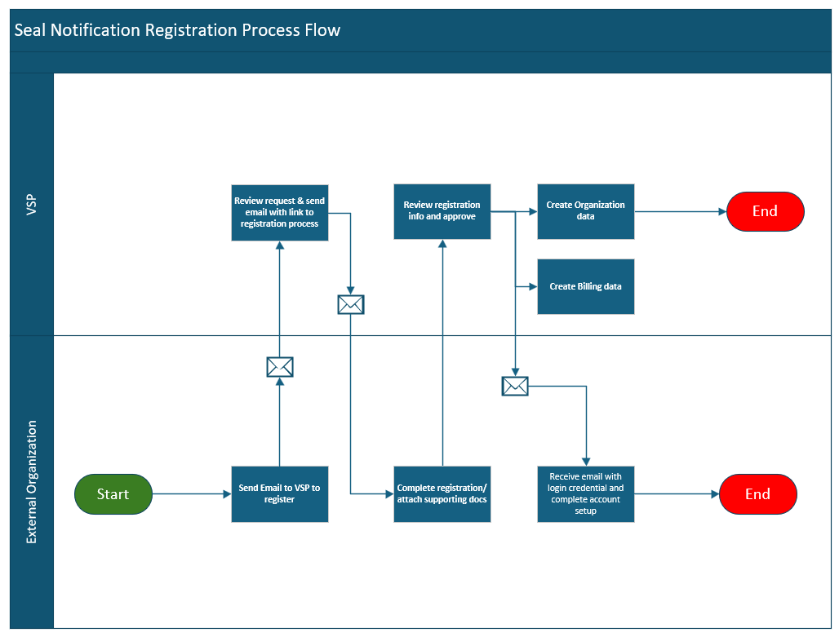

1.4 Seal Notification Workflow

The following process flow diagram presents the general process flow prescribed by the enabling legislation:
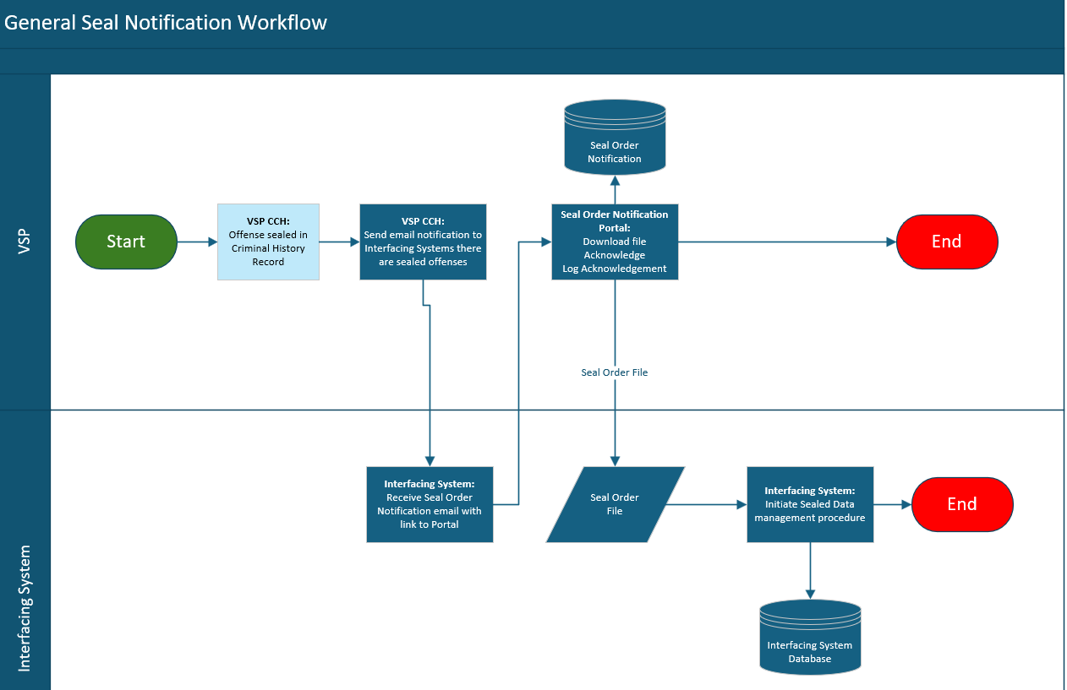

1.5 Seal Order Notification Email

A file will be generated on a periodic basis (daily or weekly) that contains all seal orders that were received since the last run. An email will be sent to each registered account to notify them that there is a file ready for download. Below is a sample email:

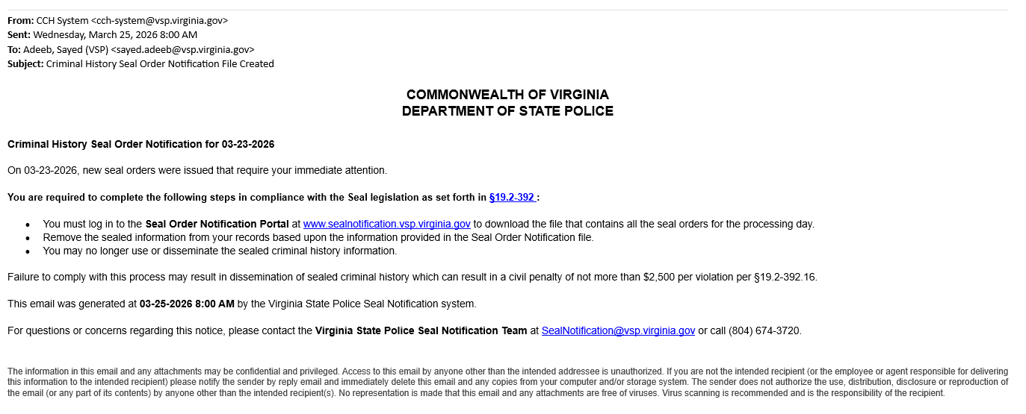
SAMPLE

1.6 Seal Order Notification Portal

A secure portal will be provided to facilitate the download of the Seal Order Notification file and provide acknowledgement that the company has received the seal order information. This will serve as acknowledgement that the company is taking the appropriate action to seal the information in their system.

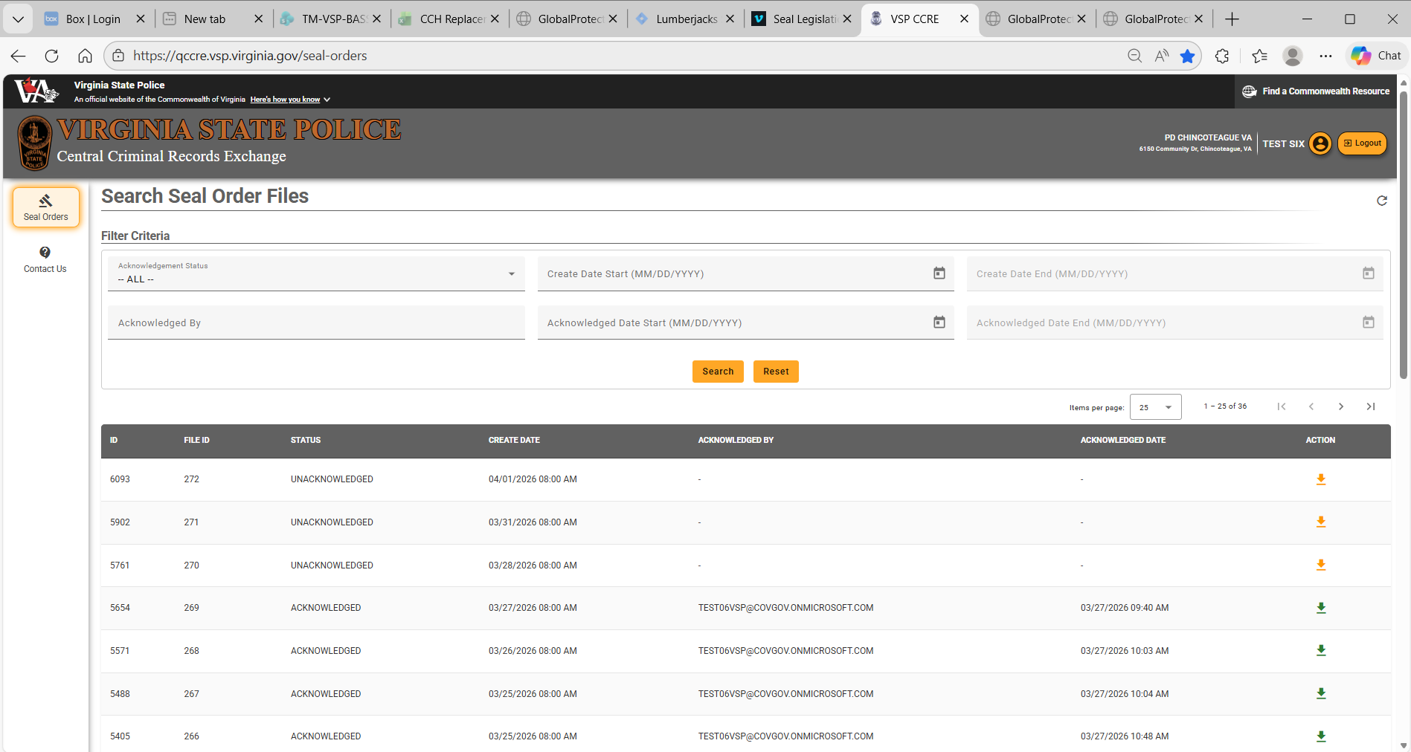
SAMPLE

2. File Specifications
This section presents the specifications for the information in the file. Per the Code of Virginia (COV), VSP must provide notifications to any entity that may have received criminal history information that is related to the seal orders. The seal notification file utilizes a single format used to provide seal order notification to all entities and is not customized for any entity.

2.1. File Format

The Seal Order Notification file will be a pipe delimited file. It will contain a record for each seal order. If an individual has 2 offenses sealed, there will be 2 records in the file.

2.2. File Definition

The following data elements are in the Seal Notifications file:

 |  |  | VSP to Interfacing System Seal Notification
 | Data Element | Data Type | Data Length | Format | Possible Values
Seal Order Information
 | Interfacing  System Seal  Notification  Batch ID | AN | 8 | XXXXXXXX
 | Seal Order ID | AN | 18
 | Order Type | A | 9 |  | This field is used to designate seal or unseal. Spaces will be padded on the end.  - “S” - Seal Notification (Seal notification communicates that this criminal history must be deleted and cannot be disseminated to anyone)  - “V” – Void Seal Notification (Void Seal indicates that the courts have determined that the seal or criminal history is no longer valid)
 | Order Legal Authority | A | 20 |  | The section of the Virginia Code that authorizes the sealing of the criminal history information
 | Court Case  Number | AN | 15 |  | Unique identifier assigned by the court for the case
 | Seal Order Date | D | 8 | YYYYMMDD
 | Disposition Code | AN | 4 |  | Abbreviation to summarize the outcome of the case. Ex: (G -Guilty, D - Dismissed, DD – Deferred, GA – Guilty in Absentia, etc.)
 | Disposition Description | AN | 20 |  | Short description of the disposition
 | Disposition Date | D | 8 | YYYYMMDD | Date the case was decided
 | Disposing Court ORI | AN | 9 |  | Standard unique identifier for the court
 | Court FIPS | AN | 4 |  | Standard unique identifier of the court’s geographic location
 | Court Name | AN | 100 |  | Name of Court
Charge
 |  | VSP to Interfacing System Seal Notification
 | Data Element | Data Type | Data Length | Format | Possible Values
 | Offense  Tracking  Number | AN | 15 |  | Unique identifier of the offense
 | Document  Control  Number | AN | 7 |  | Unique identifier of charge document
 | Code Cite | AN | 20 |  | The charge identifier per the Code of Virginia
 | Option Code | AN | 1 |  | Variation identifier
 | Code Cite Desc | AN | 50 |  | Description of the code cite charge
 | Code Cite  Modifier  Code | AN | 1 |  | Modifies the designation of a felony charge (A – Attempted, C – Conspiracy, F – Felony)
 | Case Type | AN | 2 |  | Classification of charge (M – Misdemeanor, F – Felony)
 | Case Locality or State Indicator | A | 1 |  | S – State, L - Local
 | VCC | AN | 20 |  | Virginia Crime Code identifier
 | Original/Ame nded Charge | A | 15 |  | Original, Amended
Person
 | First Name | A | 50
 | Middle Name | A | 20
 | Last Name | A | 50
 | Name Suffix | A | 4
 | Date Of Birth | D | 8 | YYYYMMDD
 | Sex | A | 1
 | SID | AN | 10 |  | Virginia State Identification Number
 | SSN | AN | 9
 | Alias Name 1 | A | 30 |  | Free form name field. Any commas will be removed and replaced with spaces. There will only be one space between name elements.
 | Alias Name 2 | A | 30 |  | Free form name field. Any commas will be removed and replaced with spaces. There will only be one space between name elements.

DATA TYPE LEGEND

A= Alphabetical Characters; AN=Alphanumeric; N = Numeric; S = Special Characters; D = Date; M = Mandatory; O = Optional; C = Conditional

